***This file provides the guide for the game “GUESS THE NUMBER”:***

***Here is it how the main window looks like:***

***Click on GUESS THE NUMBER:***

***­­­­­­­***

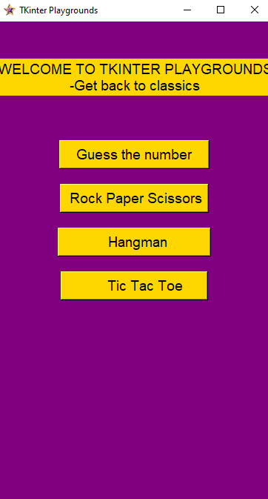

1. ***If you select GUESS THE NUMBER:*** 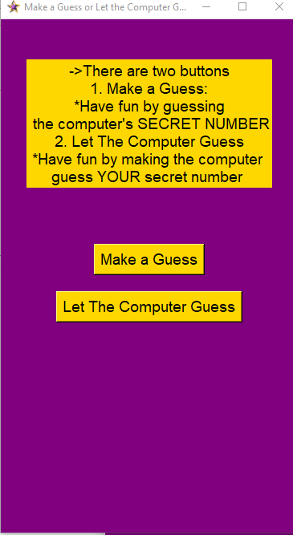

* ***If you select MAKE A GUESS:***

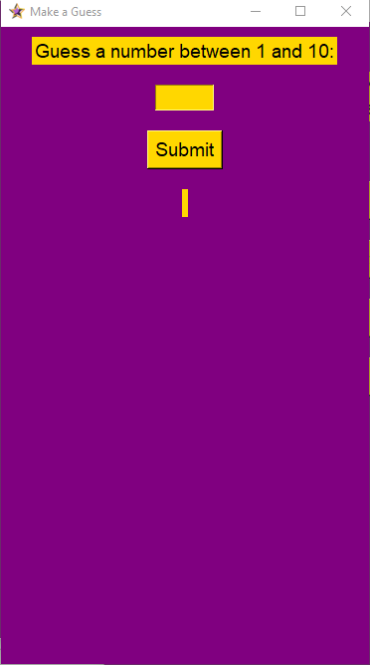

1. ***If you want to play LET THE COMPUTER GUESS***

* ***Click on it:***
* ***Then this window pops up:***

